SIMATS ENGINEERING

Name : Atsayaa .R
Reg no : (192412024)

ITA0606-
Machine learning

Experiment 1

Implement and demonstrate the FIND-S algorithm for finding the most specific hypothesis based on a given set of training data samples.
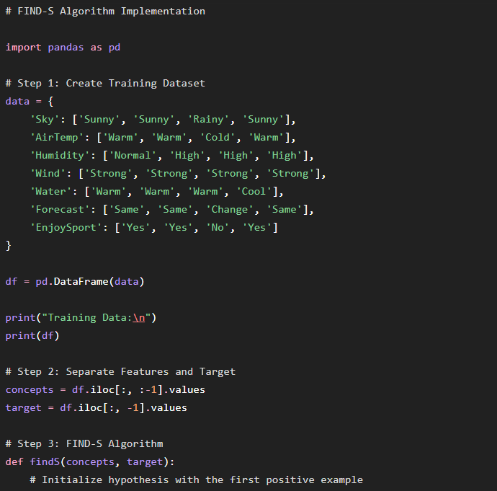
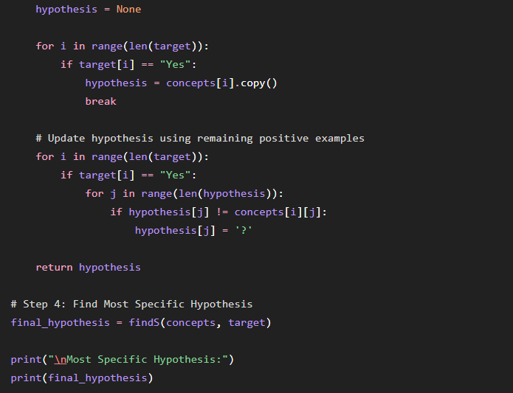

OUTPUT :
